Calibration Slope Questions

Introduction
In recent meetings, several issues have arisen regarding methods of internal model validation in clinical risk prediction. Much of the difficulty centres around calibration as a measure overfitting, and the capacity for internal validation methods to estimate it.
A simple scenario is assumed with 10 predictors, with each $X_{i} \sim N\left(0,1\right)$, for $i∈\{1, …, 10\}$. For the DGP, the chosen $β$-coefficients represent a mix of weak and strong effects ranging from $-1.8$ to $+1.2$, and the intercept has been calculated as $α= -3.0038$ to ensure a marginal prevalence of $\overline{y}=0.15$.
The simulation has revealed some interesting results, including negative or zero correlations between internally-estimated and ‘true’ calibration slopes using the Bootstrap, and discrepancies between results from Sample Splitting and Cross Validation. In this note, I address some questions that arose during discussion in the last supervision.

Is the sample size calculation parameterised correctly?
There was first some housekeeping to do. In a previous version, I had incorrectly set $c=0.85$ as a default in the `samplesizedev` package. In fact, I needed to calculate the required C-statistic from a large draw of data from the DGP. I added a return_auc=TRUE option to the DGP function and returned the relevant statistic from the pROC::auc() function. This resulted in $c=0.8995$ on average (there is some small variability in it), which I then supplied as a parameter to Pavlou et al.’s package:
> samp_size_calc <- samplesizedev(outcome = "Binary", S = 0.9, phi = 0.15,
c = 0.8995, p = 10)
> sample_size <- samp_size_calc$sim

$S=0.9$ is set as the target calibration slope for our model. The resulting sample size is 592. We have therefore now calculated the sample size requirement correctly.

Are the data being drawn correctly?
The choice of when in the simulation to draw development and test datasets can make a difference to the results, but the differences are subtle. In the previous version of my script, I drew two separate development datasets, one for the ‘true’ slope calculation and one for the bootstrap-corrected slope. This appears to be incorrect and I have now amended the code such that the development data is drawn once and fed into both the true_slope calculation and the bootstrap_est_slope calculation. Following Efron’s formulation of the prediction problem, we draw one training set x per simulation and define ‘true’ performance by evaluating the fitted rule on an large future draw from the same data-generating distribution independently of x, with x treated as fixed.
Using the required sample size of 592, the correlation plot then reveals that the near-zero variability problem for the bootstrap estimator is ameliorated.
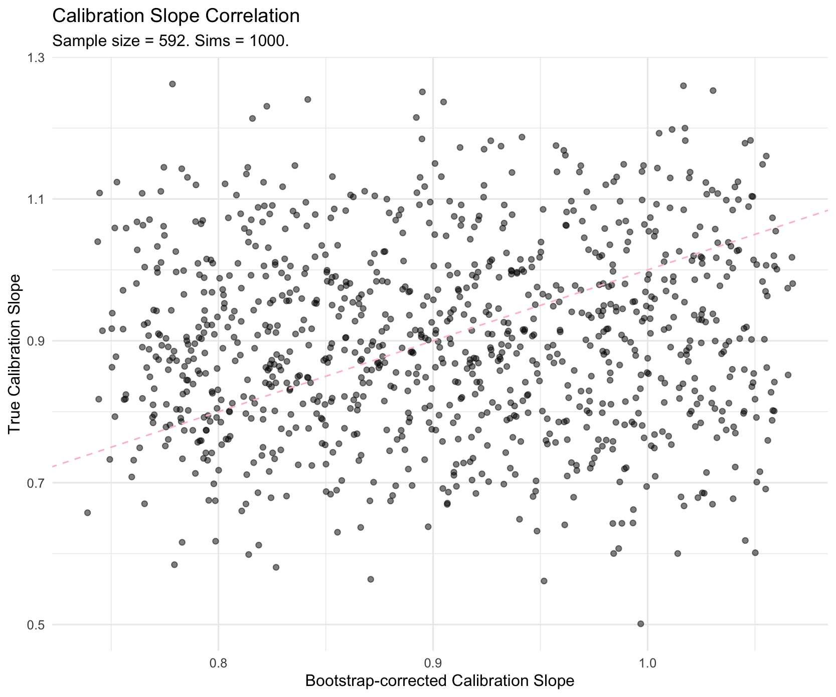
There is now reasonably detectable variability in both slope distributions, although the bootstrap is less likely to reach the more extreme slopes than the ‘true’ calculation. So that allows variability on at least the right order of magnitude for the two to be comparable.
This shows little to no correlation between the two slopes, which is our metric of interest. However, for code-testing purposes I ran a smaller simulation with an insufficient sample size (so that it would run quickly) and found a positive correlation between the two using $N=120$.
In this version, the model remains the same ($k=10$) but we have used a development dataset that is only $≈1/5$ of the required size.
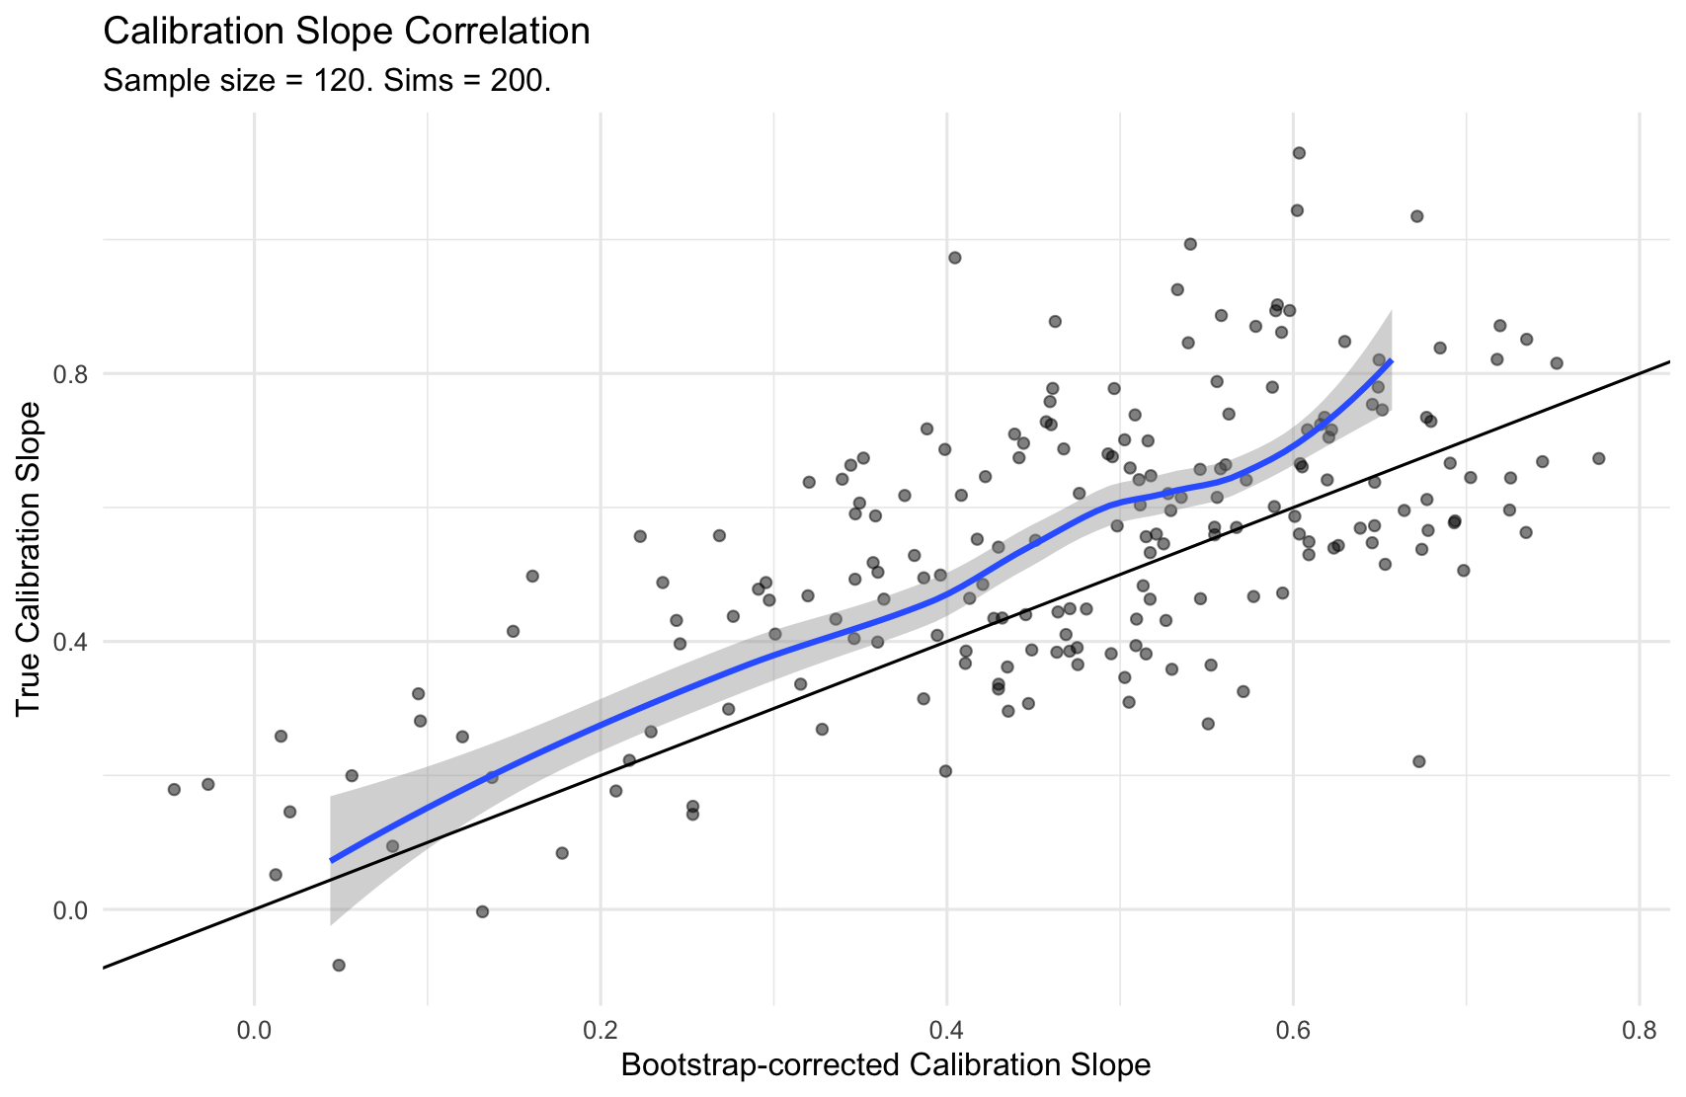
Here, the range of calibration slopes now extends down towards 0, and the upper range of the true slopes remains higher than the upper range of the bootstrap-estimated slopes. I re-ran the $N=120$ scenario with $1000$ simulations, fixing the axis scales to $(x, y) ∈{[0, 1.2]}^{2}$. This shows a hard upper limit to bootstrap slopes $<0.75$.
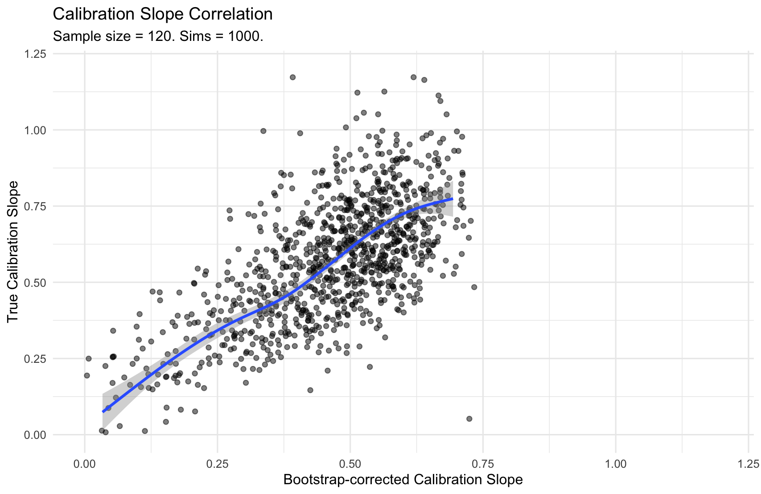
This appears to be a positive result. However, appearances can be deceiving. Firstly, the positive relationship describes a scenario that is theoretically unjustified; we have no good reason to undersample our data in this way. This is probably reflected in the second problem, which is the hard upper limit to bootstrap-estimated slopes. The target slope was $S=0.9$, which is unachievable in this scenario. And the third problem is an extension of this; there are many calibration slopes at very low values e.g., 0.25, which indicate massively overfitted models.
However, can we take anything from this? Would it be worth exploring a model fitting procedure with subsampling and regularisation, and some way of re-combining models and data? The goal would be to capitalise on the positive relationship revealed in the insufficient-N scenario, but this may amount to unprincipled machine learning.

Does testing the Bootstrap in another bootstrap resample change the result?
In supervision, we discussed the standard practice of drawing a bootstrap resample with replacement, training a bootstrap model on this resample, and then testing it for calibration back in the original data (from which the resample was drawn). However, we questioned whether this is the only way of testing; could we in fact test the bootstrap model in another, separate, bootstrap resample? The idea here was to introduce more variability into the estimate so that it doesn’t collapse into a very narrow range, but this may no longer be needed given the above change in code.
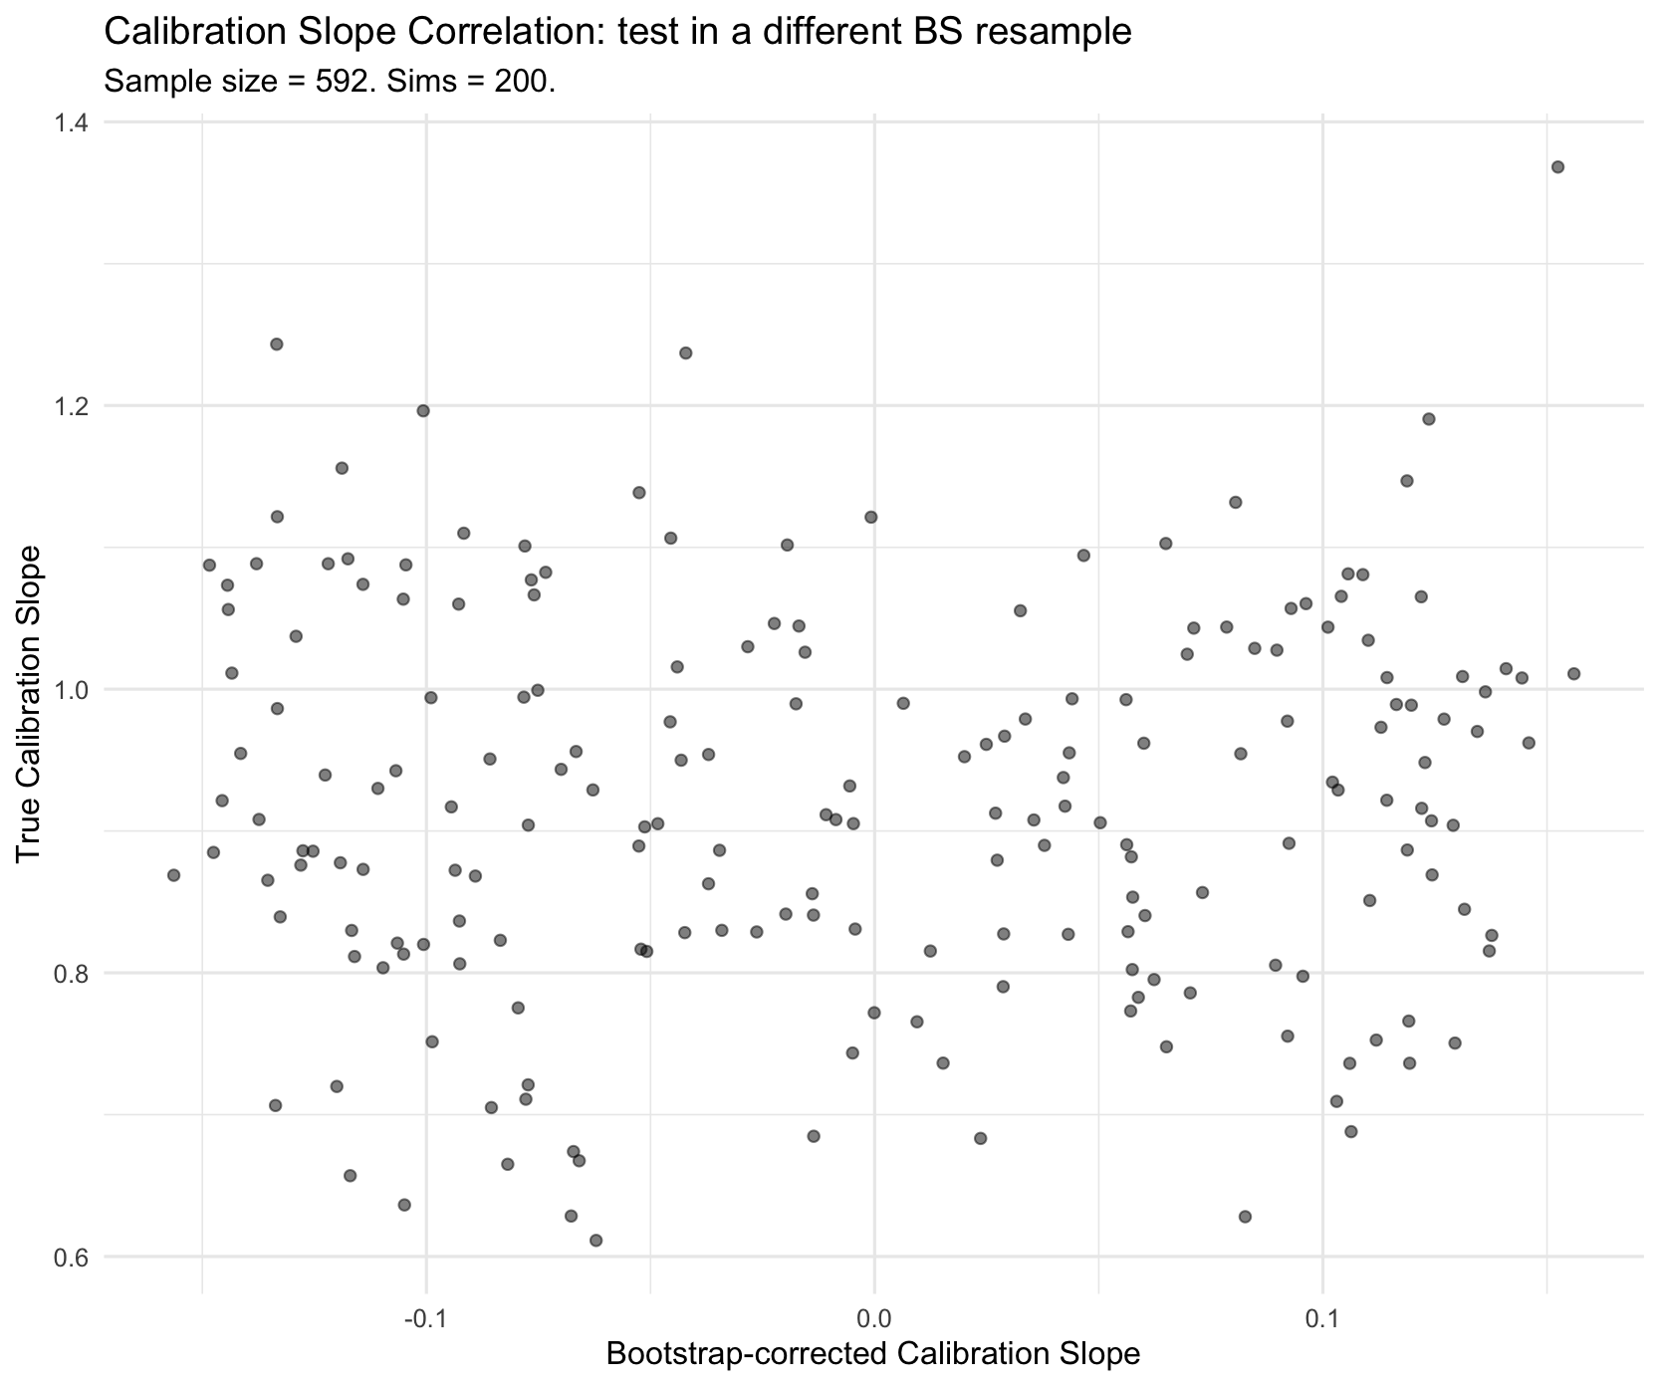
Here, not only is there no discernible relationship between the two, the bootstrap estimates are centred closely on zero with far less variability than above. This is probably not a useful innovation (and I have removed it from the saved code on GitHub.)

Why does the Bootstrap test on original data only?
In supervision, we discussed the possibility of testing the bootstrap-trained models on other test-sets, such as another (separate) bootstrap resample or indeed the out-of-bag records not selected in the first bootstrap. In question 3 above I showed quasi-empirically that testing on another bootstrap sample does not yield anything useful, but Efron (1983) takes a principled view.
Using a simplified prediction set-up, he takes the prediction problem to be a dichotomous outcome that can either be correctly predicted or incorrectly using a prediction rule, $η$. His objective is to estimate the optimism of the in-sample prediction error rate as the difference between the true error rate and the apparent error rate.
To do this he starts with a single observation $x_{i}=(t_{i}, y_{i})$, where:
- $t_{i}$ is a vector of input variables for the $i^{\text{th}}$observation from $T$, and
- $y_{i}$ is the ‘dichotomous’ actual outcome for the $i^{\text{th}}$ realisation of $Y$
The training data, then, is a set of observations $x=(x_{i}, x_{2},x_{3},…, x_{n})$, and the prediction rule trained on $x$ generates predictions on $t$, denoted $η(t, x)$. He takes $x$ to be a random sample from some distribution $F$,
$$X_{1},X_{2},X_{3},…, X_{n} \overset{iid}{\sim } F$$
and for convenience he denotes a future observation as $X_{0}=(T_{0},Y_{0})$. Future predictions $y_{0}= η(t_{0}, x)$ have an error rate given by $Q$,
$$Q\left[y_{0}, η_{0}\right]=\left\{\begin{aligned}0 \text{if }η_{0}=y_{0} \\ 1 \text{if }η_{0}≠y_{0}\end{aligned}\right.$$
Since the new case is a draw from a random variable, we can take the error function’s expectation to denote the true error rate, $Err$:
$$Err=E_{F}[Q\left[Y_{0},η\left(T_{0}, x\right)\right]]$$
Efron is interested finding the optimism, $op=Err - \overline{e}rr$, where $\overline{e}rr$ is the apparent error rate analogously calculated in the training sample:
$$\overline{e}rr= \frac{1}{n} \sum_{i=1}^{n}{Q[y_{i}, η(t_{i}, x)}]$$
Clearly $\overline{e}rr<Err$ since the prediction rule $η(t_{i},x)$ will have learned the peculiarities of the training data $x$ (overfitting). Efron’s strategy is to estimate the true error rate as $Err= \overline{e}rr+op$. Since we can calculate $\overline{e}rr$ easily with our training data, his objective is to quantify the optimism, $op$, by shifting from the real world to a simulated world in which the true error and apparent error are shifted down by one conceptual step.
Efron takes $\hat{F}$ to be the empirical probability distribution as the best available proxy for $F$, putting equal mass on each observed case:
$$\hat{F}: \text{mass} \frac{1}{n} \text{on }x_{i}, i=1,2,…,n$$
He then constructs the sampling analogue taking $X^{*}$ to be a random sample of size $n$ from $\hat{F}$,
$$X_{1}^{*},X_{2}^{*},…,X_{n}^{*}\overset{iid}{\sim }\hat{F}$$
and finally takes the bootstrap-estimate of the true error to be
$$\hat{E}rr^{\left(BOOT\right)}=\overline{e}rr+{\hat{ω}}^{(BOOT)}$$
where ${\hat{ω}}^{(BOOT)}$ is the nonparametric maximum likelihood estimate $ω\left(\hat{F}\right)$.
So the principled reason Efron provides for testing the bootstrap-trained model in the original data (rather than another bootstrap resample, for example) is that the empirical distribution is the best available approximation for the true data-generating process (which remains unknown), and the bootstrap resamples with constant probability are the best available analogs for a new sample $X_{0}$ of size $n$ from $F$. Efron treats the empirical distribution $\hat{F}$ (the nonparametric MLE of $F$) as a stand-in for the unknown population distribution, and uses $B$ bootstrap resamples $X_{j}^{*}∼\hat{F} (j=1, 2, .., B)$ to find the estimated the optimism term $ω\left(\hat{F}\right)$.
Summarising this in table form, we can see the analogs used in the bootstrap logic.
Concept | Real World | Bootstrap World
The Model | $$η\left(⋅,x\right)$$ | $$η\left(⋅,x^{*}\right)$$
‘True’ Error | Test on $F$ (Population) | Test on $\hat{F}$ (Original Data $x$)
Apparent Error | Test on $x$ (Training Data) | Test on $x^{*}$ (Bootstrap Data)
Optimism | $$op=\text{True}-\text{Apparent}$$ | $$op^{*}=\text{Bootstrap True}-\text{Bootstrap Apparent}$$

Where did the negative correlation come from? (And is it right?)

Can we reintroduce more variability to the estimator with a double-Bootstrap procedure?

How should we handle CV-aggregation?

Why is the correlation sign different between hold-out and CV?

Can we design a CV-Bootstrap hybrid procedure?

Ambler’s Empirical Bayes

